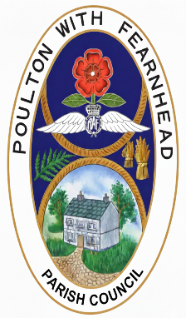
Poulton with Fearnhead Parish Council
Fearnhead Community Centre
Insall Road
Padgate
Warrington
WA2 0HD

Bank Reconciliation: 25.26 (31.03.26)

Income
Balance at 01.04.25 56,523.51
Income to 31.03.26 213,157.23
TOTAL 269,680.74
Expenditure
Payments to 31.03.26 225,142.96

BALANCE 44,537.78

Prepared by: John Perry (02.04.26)
Contact details:
Poulton with Fearnhead Parish Council
Clerk Email: clerk@pwf-pc.gov.uk
Website: https://pwf-pc.gov.uk/

